Experiment 2

Student Name: Pushpit kumar gaur UID: 24BAI70534

Branch: CSE - AIML Section/Group: 24AIT_KRG G1

Semester: 4 Date of Performance: 16/1/26

Subject Name: DBMS Subject Code: 24CSH-298

## **Aim**

To understand and implement SQL SELECT queries using various clauses such as WHERE, ORDER BY, GROUP BY, and HAVING to retrieve and manipulate data efficiently from relational database tables.

## **Software Requirements**

* Database Management System:
  + PostgreSQL
* Database Administration Tool:
  + pgAdmin

### **Objectives**

* To practice writing SQL SELECT statements.
* To apply filtering conditions using the WHERE clause.
* To sort query results using the ORDER BY clause.
* To group records using the GROUP BY clause.
* To filter grouped data using the HAVING clause.
* To analyze data using aggregate functions like COUNT(), SUM(), AVG(), MIN(), and MAX().

## **Problem Statement**

An organization maintains an EMPLOYEE table to store details of its employees.

The structure of the table is as follows:

|  |  |
| --- | --- |
| Column Name | Data Type |
| emp_id | NUMBER |
| emp_name | VARCHAR |
| Department | VARCHAR |
| Salary | NUMBER |
| joining_date | DATE |

## **Code**

CREATE TABLE EMPLOYEE(

EMP_ID NUMERIC PRIMARY KEY,

EMP_NAME VARCHAR(20),

DEPARTMENT VARCHAR(20),

SALARY NUMERIC(10,2),

JOINING_DATE DATE

)

SELECT * FROM EMPLOYEE

INSERT INTO EMPLOYEE VALUES(1, 'Aman', 'IT', 30000, '2023-05-23');

INSERT INTO EMPLOYEE VALUES(2, 'Sam', 'IT', 25000, '2016-05-23');

INSERT INTO EMPLOYEE VALUES(3, 'Neha', 'HR', 18000, '2025-09-19');

INSERT INTO EMPLOYEE VALUES(4, 'Suman', 'Finance', 20000, '2021-11-06');

INSERT INTO EMPLOYEE VALUES(5, 'Rohan', 'Finance', 50000, '2023-10-23');

NSERT INTO EMPLOYEE VALUES(6, 'Sarika', 'HR', 28000, '2020-05-16');

INSERT INTO EMPLOYEE VALUES(7, 'Dardon', 'IT', 26000, '2021-07-07')

SELECT DEPARTMENT, AVG(SALARY)::NUMERIC(10,2) AS AVG_SAL FROM EMPLOYEE

GROUP BY DEPARTMENT

SELECT EMP_ID, EMP_NAME, SALARY

FROM EMPLOYEE

GROUP BY EMP_ID

HAVING SALARY>20000

SELECT DEPARTMENT, AVG(SALARY)::NUMERIC(10,2) AS AVG_SAL FROM EMPLOYEE

GROUP BY DEPARTMENT

HAVING AVG(SALARY)>30000

SELECT DEPARTMENT, AVG(SALARY)::NUMERIC(10,2) AS AVG_SAL FROM EMPLOYEE

GROUP BY DEPARTMENT

ORDER BY AVG(SALARY) DESC

## **Output**

Table created

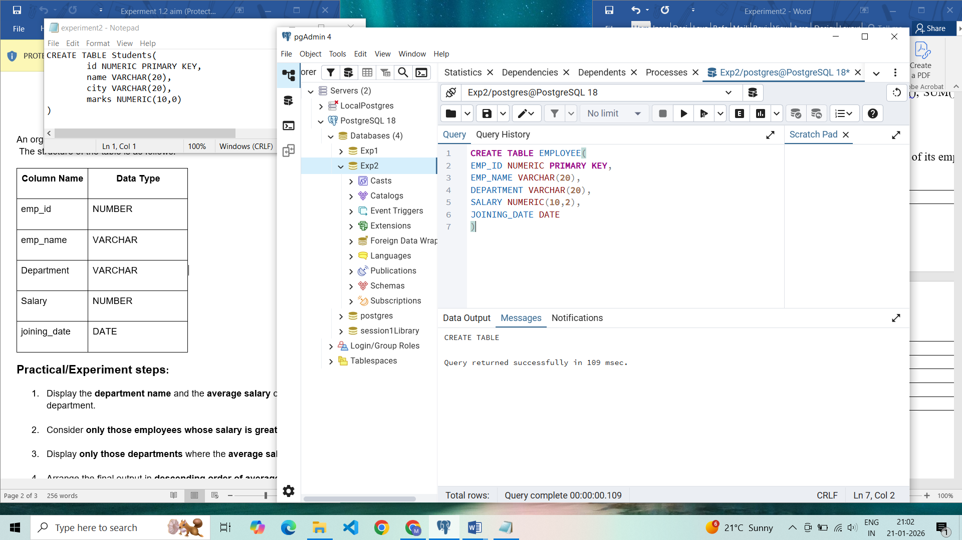

Records inserted

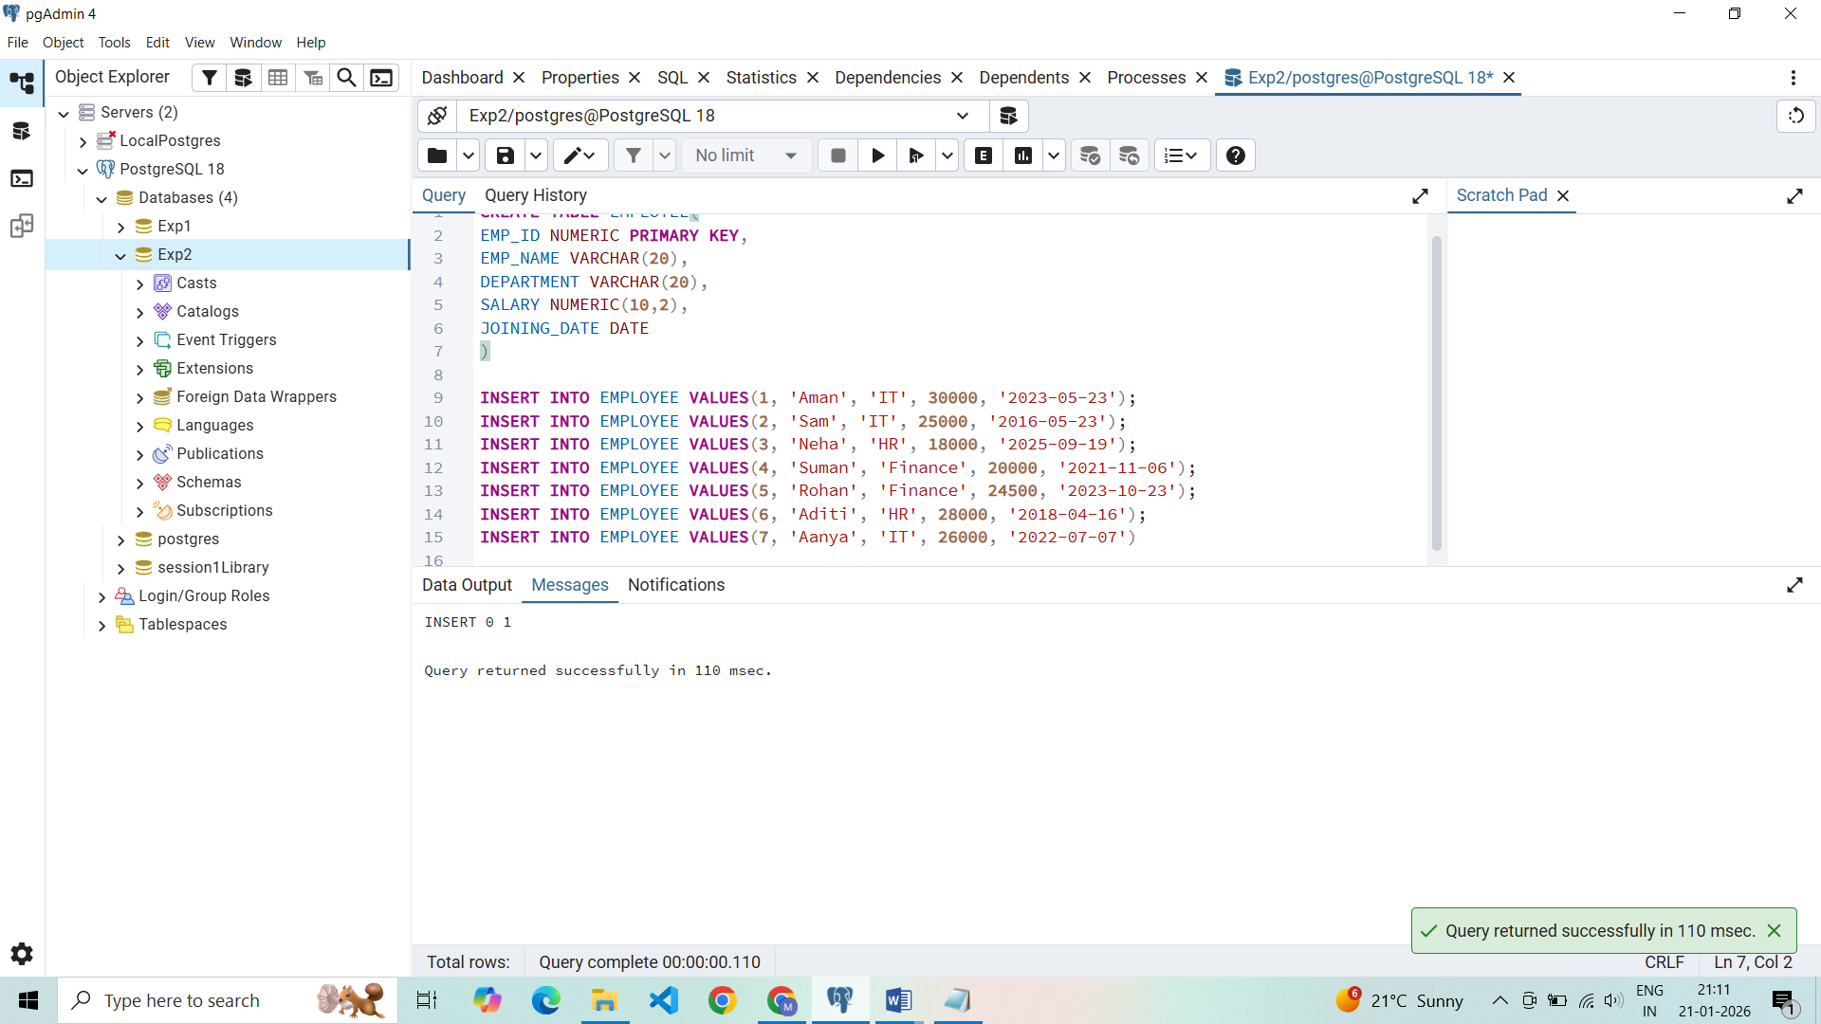

Employees with salaries greater than 20,000

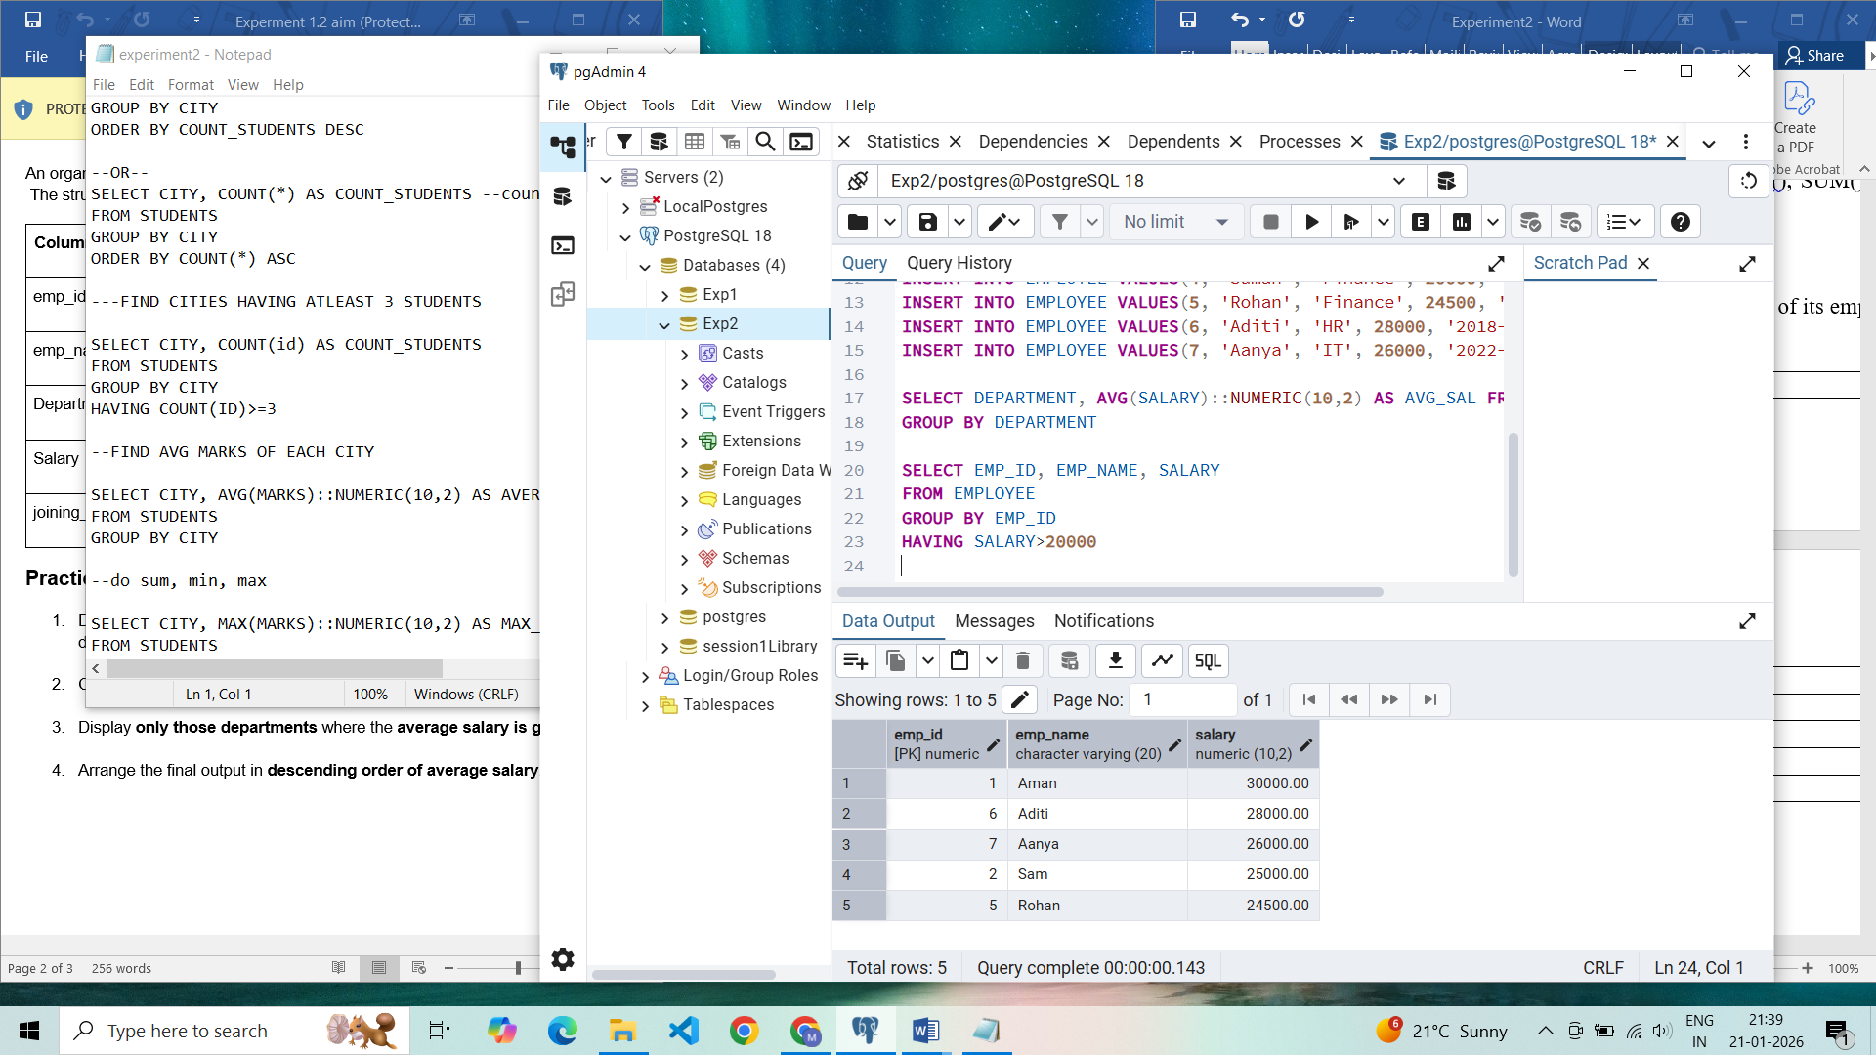

Average salaries of department

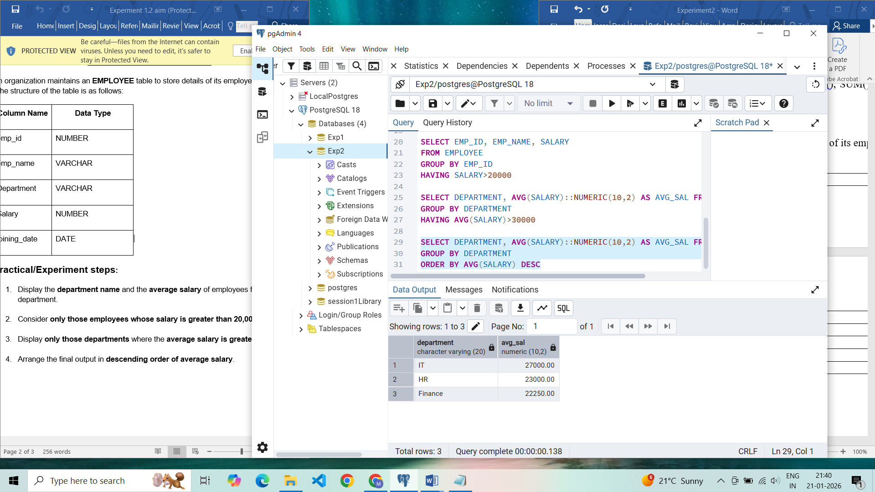

Sorting average salaries in descending order:

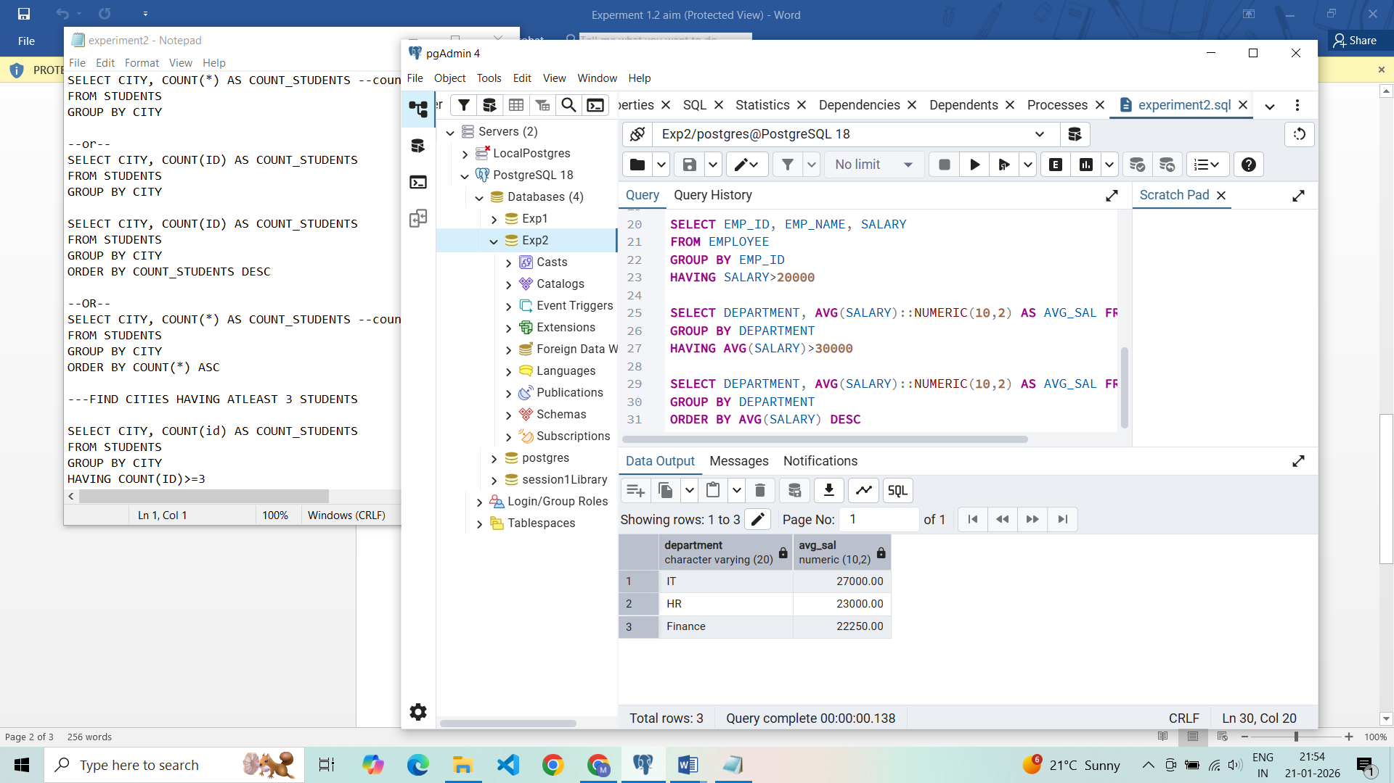

Departments with average salary more than 30,000 (empty because none)

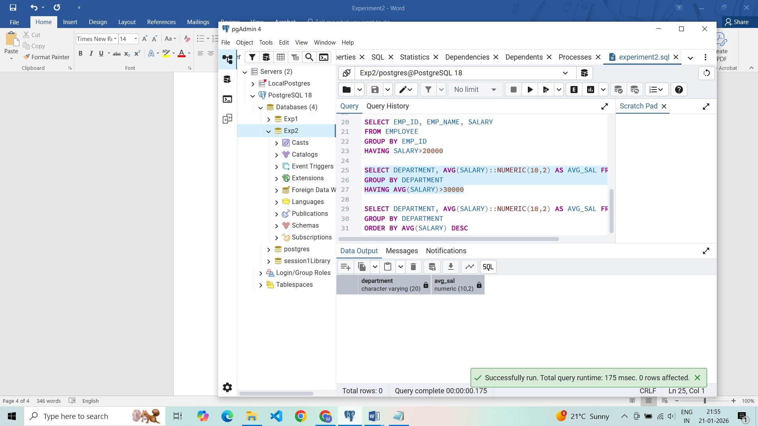

## **Learning Outcomes**

* Learn to filter records using the WHERE clause.
* Group records using GROUP BY.
* Apply conditions on grouped data using HAVING.
* Sort query results using ORDER BY.